The Washington State Energy Code:
Certification for Inspectors and
Plan Reviewers for the
Non-Residential Energy Code
by
Rick Kunkle
Washington State University
Cooperative Extension Energy Program

Prepared under an Exemplary Award
for the U.S. Department of Energy’s
Building Standards and Guidelines Program


January 1997
WSU/EEP 97-009
This case study is one in a series documenting successful building energy code programs for use by other states as technical assistance models in support of the U.S. Department of Energy (DOE) Building Standards and Guidelines Program.
The primary issue addressed by the Program (and other programs at DOE) is that new commercial and residential buildings being designed, built and occupied do not use currently available, technically feasible, and economically justified technologies and practices to eliminate the wasteful use of energy. The Program seeks to advance the energy-conserving design and construction of buildings by promoting and assisting the development and implementation of energy efficient codes and standards that are technically feasible, economically justified and environmentally beneficial. These activities are required of DOE by Title III of the Energy Conservation and Production Act as amended by the Energy Policy Act of 1992 (EPACT). The long-term goal of the Program is to make sustainable, energy-efficient building design and construction common practice.
The Program’s approach to meeting this goal is to initiate and manage individual research, standards and guidelines development efforts that are planned and conducted in cooperation with representatives from throughout the buildings community. Current projects involve practicing architects and engineers, professional societies and code organizations, industry representatives, and researchers from the private sector and national laboratories. Research results and the technical justification for standards criteria are provided to standards development and model code organizations and to federal, state and local jurisdictions as a basis to update their codes and standards. This approach helps to ensure that the standards incorporate the latest research results to achieve maximum energy savings in new buildings, yet remain responsive to the needs of the affected professions, organizations and jurisdictions. It also assists in the implementation, deployment and use of the codes and standards.
Eric Makela Margo D. Appel
Pacific Northwest National Laboratory U.S. Department of Energy

Table of Contents
Table of Figures
Acknowledgments
Executive Summary
Introduction: What is the Washington State Energy Code?
Energy Code Administration
Historical Perspective
The Energy Code in Action - Who Does What
Certification for Inspectors and Plan Reviewers for the Non-Residential Energy Code in Washington State
What is the history of non-residential energy codes in Washington State?
Why energy code certification?
What is the history of energy code certification in Washington State?
Why was the SPE/I Certification Program established?
What were the elements of the NREC Enforcement Program?
SPE/I Enforcement Mechanism
Alternative Enforcement Mechanism
Local Government Coordination
What was the process for establishing and delivering the SPE/I certification program?
What were the key elements of the SPE/I certification program?
What were the costs of the SPE/I Certification Program?
Who participated in the SPE/I Certification Program?
What was the demand for SPE/I?
How did SPE/I certification support compliance?
What does the future hold for continued SPE/I certification in Washington?
What are the barriers to extending energy code certification to other states or nationally?
Lessons Learned
Bibliography

Table of Figures
Figure 1: Chronology of Major Energy Code Efforts in Washington State
Figure 2: Responsibilities for Functions of the Washington State Energy Code
Figure 3: The Energy Code Enforcement Model
Figure 4: Distribution of Funding for the SPE/I Certification Program

Acknowledgments
This project was funded through an Exemplary Code Grant provided through Battelle Pacific Northwest Laboratories’ Building Energy Standard Program funded by the U.S. Department of Energy. This project benefited from direction and oversight provided by the project manager, Eric Makela.
Much of the information and ideas presented in this report came from interviews with those who have been involved in developing and administering the Energy Code Certification Programs. In particular, we would like to thank the staff at the Utility Code Group for providing input and review for this report. They gave generously of their time.

The other related case studies regarding the Washington State Energy Code, prepared under the DOE Exemplary Grant, are:
- The Washington State Energy Code: Training and Publication Support for the Residential Code, by Bruce Carter
- The Washington State Energy Code: The Residential Code Monitoring Program, by John Devine
- The Washington State Energy Code: The Role of Evaluation in Washington State’s Non-Residential Energy Code, by Tony Usibelli
- The Washington State Energy Code: Energy Code Privatization - The Utility Code Group Story, by Rick Kunkle
This and the other Washington State case studies were edited and prepared by Andrew Gordon, Washington State University Cooperative Extension Energy Program.

Executive Summary
Strong energy codes are an important, low cost approach for improving energy efficiency. Without strong enforcement by local code officials and compliance from the construction industry, energy codes do not deliver the promised energy savings.
In 1991, Washington State began the process of revising its non-residential energy code (NREC). Early in the revision process, energy code compliance became an important issue. A 1991 study of compliance in a randomly drawn sample of roughly 200 buildings in Oregon and Washington concluded that compliance with the commercial energy code was roughly 50 percent in both states.
The energy code compliance study emphasized the need for strong energy code enforcement and this became an important element of the NREC revision and implementation effort. The revised NREC was greatly simplified over previous versions of the code to make it easier to comply with and enforce. The NREC allows for the use of qualified special plans examiners and inspectors (SPE/I) for required inspections pursuant to Section 1701 of the Uniform Building Code.
The SPE/I Certification Program was established to assure local jurisdictions that qualified individuals were available to provide special plans review and inspection as specified in the code. The program was purely voluntary. Local building departments had the option of enforcing the energy code themselves or using SPE/I. In addition, local building officials did not have to be SPE/I certified to provide plans review or inspection for energy code compliance.
The SPE/I Certification Program was the key element of the enforcement component of the NREC Implementation Plan. The utilities in Washington State created and funded the Utility Code Group (UCG) to fund, manage, and coordinate the Implementation Plan for the 1994 NREC. The emphasis on enforcement and certification in the Implementation Plan was due to the desire of the utility funders to make sure their investment in the 1994 NREC resulted in increased compliance with the energy code.
A certification program can increase compliance with the energy code in three principle ways:
- Ensuring Minimum Competence Levels. Certification assures that inspectors have a minimum level of knowledge. Certification allows local building code jurisdictions to use registered SPE/I and meet the enforcement requirements in the energy code.
- Long-term Professional Development. Certification establishes professional standards and benchmarks. It provides those in the industry with the opportunity to raise their professional competency and to receive recognition and credentials for doing so.
- Marketing Energy Codes. Certification increases the penetration and credibility of a code. It sends a signal that a code should be taken seriously and that someone cares about the code and how it is enforced.
The special plans examiner and inspector (SPE/I) certification program was administered by the Washington Association of Building Officials (WABO). The components of the SPE/I Certification Program included:
- Code Language: Language in the 1994 non-residential energy code (NREC) specifically allows for the use of SPE/I.
- Training: A comprehensive eight hour course was offered to prepare for the certification test. The training classes were free. The training course was developed by Building and Design 2000, a consortium of industry partners headed up by the Association of General Contractors.
- Testing: Seven certification tests for special plans examiners and inspectors were given during the three and a half year life of the program. The cost for taking the exam was 50 dollars. The tests were developed, given, and scored by the International Council of Building Officials (ICBO). WABO scheduled, marketed, and handled registration. The Utility Code Group (UCG) paid for the development of the exam and heavily subsidized the exam fee.
- List of Certified SPE/I: WABO maintained a list of certified SPE/I which was updated and provided to local building departments quarterly. The UCG developed and made available a list of certified SPE/I that were interested in providing third party plan review and inspection.
- Support Materials: The UCG developed a guidebook to provide information to building departments and permit holders on how to use the services of an SPE/I. A field guide was developed for building code officials and SPE/I on what to look for in the field to achieve compliance.
- Application: If a local jurisdiction chose to use the SPE/I program, then they directed the permit holder to contact an SPE/I and arrange for the appropriate review or inspection. The permit holder was responsible for paying the SPE/I directly for services. Local utilities provided reimbursement for these costs according to a standard fee schedule.
The total cost for the management and implementation of the 1994 NREC was a little less than five million dollars. It is difficult to identify the specific costs of the SPE/I Certification Program because it overlapped with other components of NREC implementation. The approximate cost of the SPE/I Certification Program was 250 thousand dollars. A little over half this cost was split between test development, testing, administration, and evaluation. The remainder was for the certification review training course.
As of June 1996 there were 156 registered plans examiners and 140 inspectors. Approximately 240 individuals took the plans examiners test (pass rate of 65 percent) and 350 took the inspectors exam (pass rate of 40 percent). Between 40 and 50 percent of those certified were employed by local building jurisdictions. The remainder were from the private sector, primarily engineers and energy consultants. Approximately 600 to700 individuals took the certification test preparation course.
A little over 10 percent of the local building departments used the special plans examiner or inspector enforcement mechanism. Less than 10 percent of the permitted buildings used this approach. Most local jurisdictions decided to do energy code enforcement themselves. The reasons most local jurisdictions decided to enforce the energy code themselves are related to their professional ownership of code enforcement and the desire to provide comprehensive customer service to their clients.
The certification program played a role in increasing the competency of those enforcing the code. While the use of special plans examiners and inspectors (SPE/I) was somewhat limited, many local building jurisdiction staff that enforced the energy code were certified. An energy compliance study will be completed in February 1997. Preliminary assessments suggest higher levels of energy code compliance (relative to the 1991 study), particularly in cases where an SPE/I was involved. A series of interviews with building professionals, building officials, and SPE/I suggests that communication and compliance have improved since the 1991 compliance study. The use of an SPE/I was cited as an important contributor to this. However, some felt the SPE/I was an additional complication that lengthened the permitting process.
The energy code compliance study will give a more complete picture of the value of the SPE/I certification program. We believe the program helped market the energy code, provided a professional development opportunity, raised professional standards, helped ensure a minimum competency level, provided local jurisdictions with options for enforcing the energy code, and was a mechanism for helping the building industry become more familiar with the non-residential energy code (NREC).
The administration and maintenance of the SPE/I certification program was subsidized by the Utility Code Group (UCG) as part of the 1994 NREC implementation process. In March 1997, the UCG will close and transfer its activities to industry. It is not clear whether the certification program could be self sustaining without the utility subsidy. The market for those wanting to be certified may be saturated. If the demand for certification is low, then the ability to generate revenue from the certification program declines and the need for a subsidy continues. Given the ongoing restructuring of the utility industry, continued utility subsidies will be limited.
The International Council of Building Officials, or other peer organizations such as the American Institute of Architects, Electric League, and Oregon Building Officials could take over the certification program and potentially expand it regionally and nationally. There is also discussion of creating an Energy Codes Institute that could function on a regional and national level. Expansion to other states in the region could create enough demand to sustain the SPE/I Certification Program.
Some of the factors necessary for a successful certification program include the following issues:
- Active participation of peer organizations in the certification program is critical.
- Move the certification program towards sustainability early in the implementation phase.
- Provide for use of special inspectors in energy code language.
- Tie certification into other energy code enforcement activities.
- Recognize that certification is a marketing program.
- Identify and prioritize key issues when developing training and testing.
- Realize the limitations of a voluntary program that works within the existing elements of energy code enforcement.

Introduction: What is the Washington State Energy Code?
The Washington State Energy Code provides energy efficiency standards for new and altered residential and commercial buildings in Washington State.* The first Washington State Energy Code appeared in 1978; since then, it has been revised in light of advances in building science and new energy efficient technologies.
The current versions of the Washington residential and non-residential energy codes were implemented in 1991 and 1994, respectively. The state legislature passed a bill in 1990 that upgraded energy codes for residential structures; in 1991, the legislature authorized the State Building Code Council to upgrade the energy code for non-residential structures.

Energy Code Administration
In Washington State, the legislature is given the authority to revise building codes, including the Energy Code. The State Building Code Council administers the building code and ensures that the state’s interests are met according to state law. The Council includes representatives from the building industry, local government, and code enforcement officials. Building codes are enforced by local jurisdictions. Cities and counties have building departments with code officials who conduct plan reviews and building inspections. Enforcement is funded at the local level.

Historical Perspective
The Washington State Energy Code did not appear in its present form overnight. The current code is the result of a gradual process over a period of sixteen years. Figure 1 presents a chronology of major events and efforts leading up to the current code.
Figure 1
Chronology of Major Energy Code Efforts in Washington State
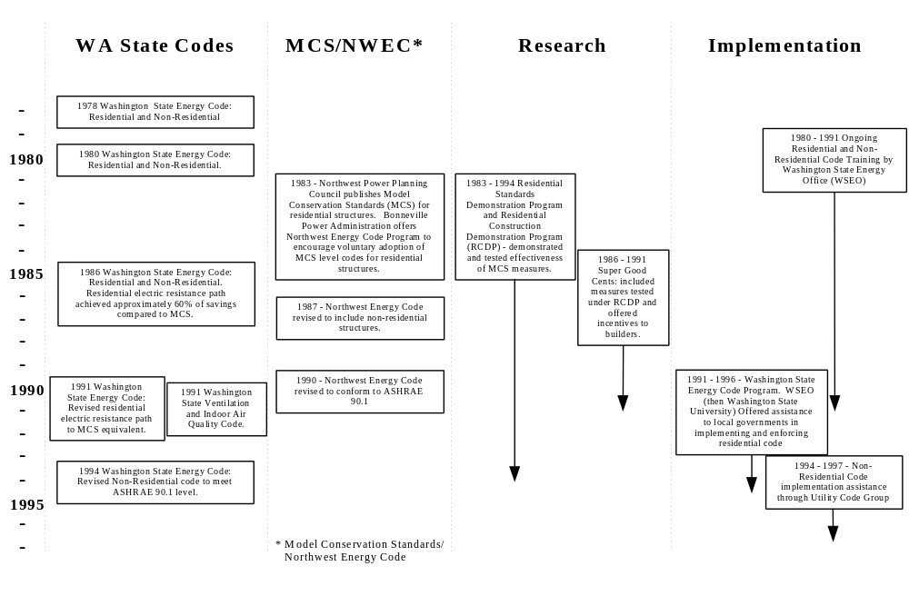

The Energy Code in Action - Who Does What
The successful functioning of both the residential and non-residential energy codes are due to participation by a number of different entities. Figure 2 outlines the functions provided by the various agencies and associations as of December 1996.
Figure 2
Responsibilities for Functions of the Washington State Energy Code

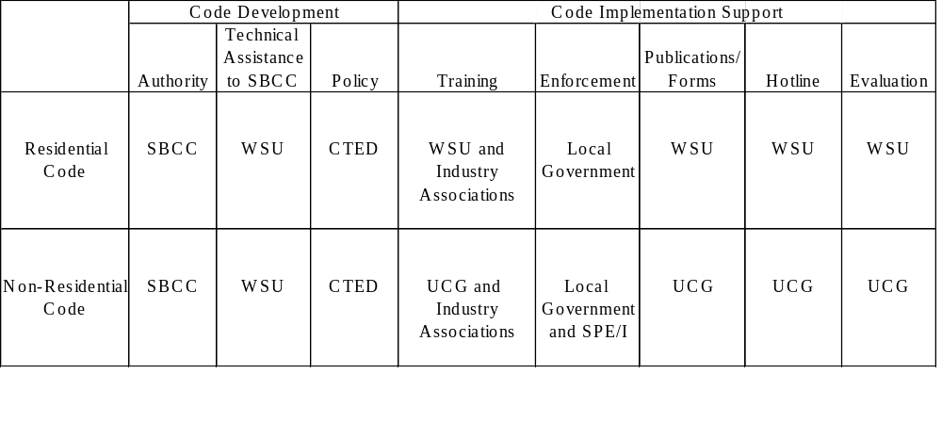Key
SBCC State Building Code Council
WSU Washington State University Cooperative Extension Energy Program - formerly the Washington State Energy Office
CTED Washington State Department of Community Trade and Economic Development
SPE/I Special Plans Examiners and Inspectors
UCG Utility Code Group - Typically acting through subcontractors

Certification for Inspectors and Plan Reviewers for the Non-Residential Energy Code in Washington State
Strong energy codes are an important low cost approach for improving energy efficiency. Without strong enforcement by local code officials and compliance from the construction industry, energy codes do not deliver the promised energy savings.
The 1994 non-residential energy code (NREC) provides for the use of qualified special plans examiners and inspectors (SPE/I) as an optional enforcement mechanism to encourage compliance with the energy code. A training and certification program was established to ensure qualified SPE/I were available. In this document we summarize the role the special plans examiner and inspector certification program has played in supporting compliance with the 1994 Non-Residential Energy Code in Washington State.

What is the history of non-residential energy codes in Washington State?
Washington was one of the first states in the country to adopt statewide energy codes in the 1970s. In 1980, Washington adopted a non-residential energy code based on the American Society of Heating, Refrigerating, and Air-Conditioning Engineers (ASHRAE) Standard 90-75. ASHRAE revised its Energy Design Standard to produce ASHRAE 90-80 and Washington incorporated these changes into its non-residential energy code in 1985. Additional lighting revisions were made in 1990.
In 1991, Washington State began the process of revising its non-residential energy code (NREC). The update to the energy code was largely driven by the desire of the region’s utilities and the Northwest Power Planning Council to increase the energy efficiency of new commercial buildings by raising the energy code up to the model conservation standard developed by the Northwest Power Planning Council.
There was resistance to the energy code revision process from the building industry and building code officials. The entire revision process was very political, from the initial legislation authorizing the State Building Code Council to revise the code in 1991, to the approval of the new code in September 1993 (with an effective date of April 1994). An Implementation Plan was developed during the revision process that specified how the code would be implemented. The plan contained many of the compromises that were reached to satisfy all the parties involved.
The Utility Code Group (UCG) was created to fund, manage, and coordinate the Implementation Plan for the 1994 NREC. It was a non-profit corporation formed by the state’s utilities. A board of utility representatives provided oversight. The Implementation Plan had three major components:
- training and education
- enforcement support and local government coordination
- quality assurance and evaluation.
The four UCG staff carried out the functions in the Implementation Plan by managing and coordinating a group of contractors and peer organizations.
The Utility Code Group (UCG) was funded by utilities. The amount contributed by each utility was based on their energy sales in Washington State. Revenue from sales of non-residential energy code (NREC) Implementation Program products and services and other funding sources was less than two percent of the funding. Over the three and a half year life of the program, expenditures were a little less than five million dollars. Education and training accounted for approximately two thirds of the total expenditures.

Why energy code certification?
An energy code certification program is a tool to increase the effectiveness of an energy code. A certification program increases compliance through:
- Ensuring Minimum Competence Levels. Mandatory certification assures that inspectors (or their alternates) have a minimum level of knowledge. In this setting, certification is much like a notarization. The option to use qualified special inspectors and plans examiners was written into the 1994 NREC. Certification ensures local jurisdictions that special plans examiners and inspectors are qualified, as required in the code.
- Long-term professional development. Certification establishes professional standards and performance benchmarks. It provides those in the industry with the opportunity to raise their professional competency and to receive recognition and credentials for doing so. It builds consistency in interpretation and supports standardized enforcement practice among code users. The testing and certification process provides a forum for identifying and discussing inconsistencies in code interpretations. Certification provides a credential for identifying qualified code enforcement staff in the hiring process. Voluntary certifications compliment broader education efforts. The recognition and credentials provide incentives to complete a larger training program. As a by-product, certification can help increase understanding of energy codes outside the code enforcement community.
- Marketing Energy Codes. Certification increases the penetration and credibility of a code. A certification, even a voluntary one, sends a signal to the building industry and code enforcement community that a code should be taken seriously and that someone cares about the code and how it is enforced. Professional standards can make those certified more purposeful in conducting business and take more pride in their knowledge. Although building inspectors are the final arbiters of compliance, having a certification in hand can give building inspectors extra confidence in standing up to architects and engineers who challenge interpretations. This is particularly valuable when technically complicated codes (e.g. non-residential ) are first adopted.

What is the history of energy code certification in Washington State?
Energy code certification has been a small but useful part of the infrastructure supporting compliance with Washington State’s energy code. Two approaches to energy code certification have been offered in Washington State since 1987. Between 1987 and 1993 the Washington State Energy Office established a voluntary energy code certification program for building inspectors and plans examiner in conjunction with the Washington Association of Building Officials (WABO). This program emphasized the residential energy code. With the adoption of the 1994 non-residential energy code (NREC) in 1993, this voluntary program ended and residential certification programs were discontinued. The special plans examiners and inspectors (SPE/I) Certification Program was established as part of the implementation of the 1994 NREC.

Why was the SPE/I Certification Program established?
Early in the non-residential energy code revision process, energy code compliance became an important issue. In 1991, the Bonneville Power Administration and the state energy offices sponsored a study of compliance with the existing commercial energy code in Washington and Oregon. On the basis of a randomly drawn sample of roughly 200 buildings in the two states, the study concluded that compliance with the commercial energy code was roughly 50 percent in both states. Follow-up interviews strongly supported this result.
The energy code compliance study emphasized the need for strong energy code enforcement and this became an important element of the NREC revision and implementation effort. The revised NREC was greatly simplified over previous versions of the energy code to make it easier to comply with and enforce. The NREC allows for the use of qualified SPE/I for required inspections pursuant to Section 1701 of the Uniform Building Code. Enforcement was one of the three key elements of the Implementation Plan. The SPE/I program was proposed as the enforcement program model in the Inspection Plan. Training and certification were established to support the SPE/I program and to assure local jurisdictions that certified SPE/I were qualified to perform this function.
The implementation of the NREC was funded by the Bonneville Power Administration and the natural gas and electric utilities in Washington State. Achieving compliance with the energy code was very important for these funders. The SPE/I certification program was one of the tools for ensuring their investment resulted in energy savings.
The SPE/I certification program supported the enforcement of the energy code for some of the following reasons:
- the SPE/I was well versed in the NREC and was accountable for his or her work,
- the local jurisdiction did not need to hire additional staff or extensively train existing staff,
- the building industry became more familiar with the NREC by working with the SPE/I, and
- the turn around time could be faster relative to jurisdictions with limited resources.

What were the elements of the NREC Enforcement Program?
The NREC Enforcement Program was a key element of the NREC Implementation Plan. It recognized that consistent enforcement was essential to achieving compliance with the commercial energy code. The goals of the enforcement program were specified in the Implementation Plan, as follows:
- Protect consumers to ensure that health and safety were met as well as lowering energy costs and ensuring that customers got what they paid for.
- Achieve efficient, thorough and consistent enforcement of the code throughout the state.
- Minimize, or avoid, additional costs to builders and local jurisdictions.
- Minimize, or avoid, any delays in permitting and the construction process due to energy code enforcement.
- Establish a comprehensive, sustainable statewide enforcement program.
The Enforcement Program was designed to be comprehensive, flexible, consistent, efficient, and standardized. The key elements of the program were the special plans examiner and inspector (SPE/I) and alternate enforcement mechanisms along with local government coordination (see Figure 3).
Figure 3
The Energy Code Enforcement Model

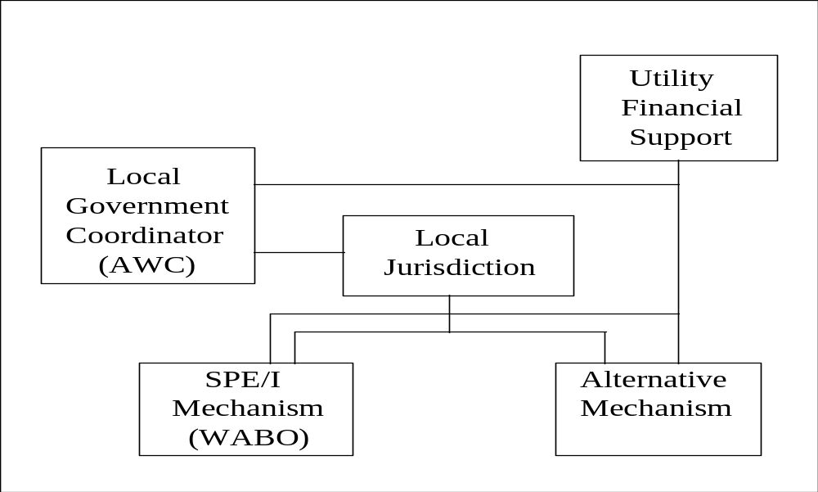

SPE/I Enforcement Mechanism
The SPE/I Program provided an optional enforcement mechanism that could be used by a local jurisdiction to enforce the non-residential energy code (NREC). The program was based on the special inspector requirements in Section 1701 of the Uniform Building Code which allow the use of special inspectors for code enforcement related to specific building elements. The SPE/I certification program tested and certified qualified SPE/I’s. If a jurisdiction chose to use an SPE/I for energy code enforcement, then the building applicant was responsible for contracting with and paying for a certified SPE/I. The SPE/I could perform all, or part of, the plans check and site inspection work, depending on the jurisdiction’s policies and requirements. The building permit holder could send proof of code compliance and the SPE/I bill to the utility for reimbursement. Reimbursement was based on a standard fee schedule.

Alternative Enforcement Mechanism
A local jurisdiction had the option to choose an alternative enforcement mechanism independent of the statewide special plans examiner and inspector (SPE/I) program. These options included:
- A local utility performed enforcement activities,
- A local utility funded the local jurisdiction to perform enforcement activities,
- A local jurisdiction performed all enforcement activities with its own resources, or
- A combination of these approaches including the use of certified SPE/I for some services.

Local Government Coordination
The Association of Washington Cities (AWC) was responsible for coordination with local jurisdictions. AWC provides a variety of services to their members such as training, information, and representation. Regarding non-residential energy code (NREC) implementation, AWC disseminated code information through newsletters, organized several code conferences that included information and training, and conducted special projects for the Utility Code Group (UCG) such as surveying their members and talking to elected officials about the code. The AWC was available to assist local jurisdictions with development of enforcement plans and model agreements and local ordinances. In addition, the AWC helped market alternative enforcement mechanisms and training and education programs.

What was the process for establishing and delivering the SPE/I certification program?
Beginning in 1994, the UCG in conjunction with the Washington Association of Building Officials (WABO) established a certification program for SPE/I.
The Implementation Plan established the framework for how the SPE/I Program would function. WABO was actively involved in the revision of 1994 NREC and as part of that political process was identified as the appropriate organization for managing the SPE/I Program. The UCG provided funding and oversight to ensure that the goals in the Implementation Plan were being met.
The UCG contracted with the International Council of Building Officials (ICBO) to establish a certification test for the SPE/I. Several contractors were involved in the development process. There was an extensive review process. The first tests were offered when the revised NREC went into effect. The UCG developed the Special Plans Examiner and Inspector Policy and Procedures Handbook on how to use an SPE/I.
WABO scheduled and promoted the exams for certification. They processed the registrations for the exams and for certification. They were the certifying body and they maintained a list of certified SPE/I which was published quarterly (UCG also maintained a list of certified SPE/I that provided third party reviews or inspections). Any challenges to the certification test were processed by WABO and forwarded to the (ICBO).
ICBO developed and maintained the certification exams. They proctored and scored the exams. They adjudicated any challenges to the exams.
Building and Design 2000 (B+D 2000) developed the preparation course for special plans examiner and inspector (SPE/I) certification. B+D 2000 was a consortium of industry partners chaired by the Association of General Contractors. B+D 2000 also developed the NREC Field Guide on what to look for in the field to achieve compliance. Beginning in January 1996, the Utility Code Group (UCG) took over the delivery of non-residential energy code training, including the certification preparation course.

What were the key elements of the SPE/I certification program?
The SPE/I Program was an optional enforcement mechanism designed to increase compliance and give local jurisdictions more flexibility enforcing the non-residential energy code (NREC). The program trained, tested, and certified qualified SPE/Is. There were support materials for the program and a process for using an SPE/I.
Code Language: Language in the 1994 NREC specifically allows for the use of SPE/I according to the special inspector requirements in Section 1701 of the Uniform Building Code. This code language provides the basis for the SPE/I certification program.
Training: A comprehensive eight hour course was offered to prepare for the certification test. The NREC Plans Examiner & Inspector Preparation was aimed at building officials, plans examiners, inspectors, engineers, contractors, and utility personnel. Those taking the course learned about all the NREC provisions and other information needed to prepare for the certification examination. The classes were offered both as one day and multi-day courses. The training classes were free.
Testing: Seven certification tests for special plans examiners and inspectors were given during the three and a half year life of the program. The cost for taking the exam was 50 dollars. The pass rate for the plans examiners test was 65 percent and for the inspectors test was 40 percent.
List of Certified SPE/I: WABO maintained a list of certified SPE/I which was updated and provided to local building departments quarterly. The UCG also maintained a list of certified SPE/I that were interested in providing third party review and inspection. As of June 1996, there were 156 registered plans examiners and 140 inspectors.
Support Materials: The Special Plans Examiner and Inspector Policies and Procedures Handbook was developed to provide information to building departments and permit holders on how to use the services of an SPE/I. A field guide was developed for building code officials and SPE/I on what to look for in the field to achieve compliance.
Application: If a local jurisdiction chose to use the SPE/I program, the process of using an SPE/I ideally contained the following steps:
- The local jurisdiction advised the permit holder of the type of work performed by a special plans examiner or inspector and the reporting requirements. The jurisdiction also provided a list of approved special plans examiners and inspectors (SPE/I).
- The permit holder was responsible for contacting a qualified SPE/I and arranging for the appropriate review or inspection according to the policies of the local jurisdiction.
- The permit holder was responsible for paying the special plans examiner and inspector (SPE/I) directly for services. A consistent statewide fee structure was established for SPE/I services, but the charges could vary depending on the services provided and the arrangements made between the permit holder and SPE/I.
- The building permit holder could send proof of code compliance and the SPE/I bill to the utility for reimbursement. Reimbursement was based on a standard fee schedule. The reimbursement rate was 100 percent from the effective date of the code (April 1994) through December 1995. The rate droped to 50 percent from January 1996 through March 1997.

What were the costs of the SPE/I Certification Program?
The total cost for the management and implementation of the 1994 non-residential energy code (NREC) was a little less than five million dollars. The enforcement program of which the SPE/I certification was a part was one component of the NREC implementation effort. Because the SPE/I certification program overlapped with other components of NREC implementation, it is difficult to precisely allocate costs to certification. The following estimates are approximations to give guidance on the magnitude of the costs for certification.
Figure 4 shows the distribution of the approximately 250 thousand dollars spent on the SPE/I certification program. A little less than half of the funding was spent on the training preparation course and related materials (this cost includes the field guide and handbook). The administration cost includes oversight provided by the UCG, and management and promotion of the program by WABO. Testing and test development covers the cost for International Council of Building Officials (ICBO) and other consultants to develop and conduct the test. A portion of the NREC evaluation costs are allocated to the SPE/I program because evaluation of the SPE/I program was an important element of the evaluation plan.
Figure 4
Distribution of Funding for the SPE/I Certification Program

(250 thousand dollars total)
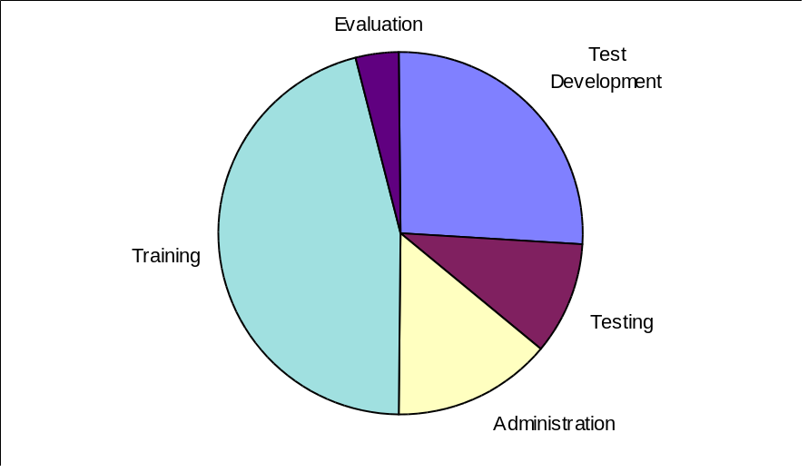
The only revenue generated by the special plans examiners and inspectors (SPE/I) Certification Program was a 50 dollar fee charged for taking the certification test. This fee generated 30,000 to 35,000 dollars. The fee would need to be 200 to 250 dollars to cover the costs of the testing program. There was no charge for the certification test preparation classes until the final set of classes, which cost 50 dollars.
These costs do not include any reimbursements paid by utilities to SPE/I for conducting plan reviews or inspections.

Who participated in the SPE/I Certification Program?
As of June 1996, there were 156 registered plans examiners and 140 inspectors. Approximately 240 individuals took the plans examiners test (pass rate of 65 percent) and 350 took the inspectors exam (pass rate of 40 percent). Between 40 and 50 percent of those certified were employed by local building jurisdictions. The remainder were from the private sector, primarily engineers and energy consultants. Approximately 600 to 700 individuals took the certification test preparation course.

What was the demand for SPE/I?
A little over 10 percent of the local building departments used the special plans examiner or inspector enforcement mechanism. Less than 10 percent of the permitted buildings used this approach.
Most local jurisdictions decided to do energy code enforcement themselves. A little less than half the certified special plans examiners and inspectors (SPE/I) were building jurisdiction staff. Some building jurisdiction staff took the certification preparation course and other non-residential energy code (NREC) training, but did not take the certification test.
The reasons most local jurisdictions decided to enforce the energy code themselves are related to their professional ownership of code enforcement and the desire to provide comprehensive customer service to their clients. Local building code officials believe they are well versed in all aspects of the building code, while the SPE/I have a limited specialty. The local building code official can do multiple inspections, including energy. They believe that when local building officials enforce the energy code, the whole building code enforcement process is less fragmented.

How did SPE/I certification support compliance?
The certification program played an important role in increasing the competency of those enforcing the code. While the use of SPE/I was somewhat limited, many local building jurisdiction staff who enforced the energy code were certified.
In February 1997, an energy code compliance study will be completed. A preliminary compliance study was started in June 1995 on a sample of 36 buildings. Because the code had only been in effect for a year at this time, the sample was limited and not representative. It provides a case study on code implementation. The results showed compliance was 94 percent in those cases where a special plans examiner or inspector was used and was 55 percent in all other cases. It is important to note that the non-complying rate was strongly influenced by one jurisdiction that decided not to enforce the energy code, but instead relied on self-certification from the building industry.
The preliminary compliance study also incorporated interviews with building professionals, building officials, and SPE/I associated with the reviewed buildings. The results of these interviews suggested that communication and compliance improved since the 1991 compliance study. There was a four-fold increase in feedback to building professionals on code compliance (feedback was greatest in cases using an SPE/I). Twice as many architects were taking some responsibility for code compliance. Sixty percent of the building professionals indicated they felt the SPE/I aided the compliance process and expedited project review. In jurisdictions using SPE/I, 63 percent of building officials and SPE/I interviewed believed compliance was higher, 25 percent thought it was the same, and 13 percent were not sure.
However, reaction to the SPE/I program from building professionals was mixed. Some felt the SPE/I was an additional complication that lengthened the permitting process. Likewise, 50 percent of the building officials and SPE/I interviewed felt the new energy code compliance process took longer than before.
The energy code compliance study will give a more complete picture of the value of the SPE/I certification program. We believe the program helped create awareness for the energy code, provided a professional development opportunity, raised professional standards, helped ensure a minimum competency level, provided local jurisdictions with options for enforcing the energy code, and was a mechanism for helping the building industry become more familiar with the NREC.

What does the future hold for continued SPE/I certification in Washington?
The special plans examiners and inspectors (SPE/I) program was unique. State-level code organizations do not typically run this type of program. The administration and maintenance of the SPE/I certification program was subsidized by the Utility Code Group (UCG) as part of the 1994 non-residential energy code (NREC) implementation process. In March 1997, the UCG will close and transfer its activities to industry. It is not clear whether the certification program can be self sustaining without the utility subsidy. The market for those wanting to be certified may be saturated. If the demand for certification is low, then the ability to generate revenue from the certification program declines and the need for a subsidy continues. Given the ongoing restructuring of the utility industry, continued utility subsidies will be limited.
Most building code officials and staff wanting certification have received it. The demand for SPE/I services has been relatively low. There does not seem to be a great need for more SPE/I. Most building jurisdictions are enforcing the energy code themselves and are not using SPE/I. Seventy-eight percent of the building professionals interviewed in the preliminary compliance study indicated they would not use an SPE/I unless the local jurisdiction required it.
There was some concern that the phase out of utility reimbursement for the SPE/I would reduce the use of the SPE/I program. However, only 45 percent of the building officials and SPE/I interviewed felt the loss of the reimbursement would have a significant impact. More important is whether the local jurisdiction promotes or requires the use of an SPE/I.
The UCG has a contract with Washington Association of Building Officials (WABO) and International Council of Building Officials (ICBO) to deliver the SPE/I program. The contract states that if WABO and ICBO do not develop a plan to continue the program that is acceptable to the UCG, then the set of test questions (to be used in future tests) returns to the UCG, and the UCG will find a successor organization to continue the program. The WABO Board has indicated they are not interested in continuing the program using the current arrangement.
ICBO or other peer organizations such as the American Institute of Architects, Electric League, and Oregon Building Officials could take over the certification program and potentially expand it regionally and nationally. There is also discussion of creating an Energy Codes Institute that could function on a regional and national level. Expansion to other states in the region could create enough demand to sustain the SPE/I Certification Program.

What are the barriers to extending energy code certification to other states or nationally?
There could be a lot of value to extending a certification program nationally, largely from an efficiency standpoint. If the costs for implementing and administering a certification program could be spread among many states, it is likely that a self-sustaining program could be maintained. ICBO or other peer organizations could do this.
However, there is no existing national market for energy code certification. At the state level, there is little interest or support for raising energy code standards or compliance. In fact, the sentiment seems to be in the opposite direction.
Another potential barrier is dissimilar energy codes. However, this has become less of a problem with the widespread adoption of the American Society of Heating, Refrigerating, and Air-Conditioning Engineers (ASHRAE) Standard 90.1 as the core for most state and national model codes.
Increasing interest in the commercial energy code at a national level may provide critical policy support and motivation for sustaining the energy code in the states. The national Energy Policy Act legislation contains minimum energy code standards. This could serve as a motivation for the development of a national energy code effort, including certification. The U.S. Department of Energy along with some of the national labs has a Building Standards and Guidelines Program to support energy code implementation.

Lessons Learned
Some of the important factors necessary for a successful certification program include the following issues.
- Active participation of peer organizations in the certification program is critical. In this case the Washington Association of Building Officials (WABO), the peer organization for building officials, administered the certification program. It is necessary for those implementing the energy code to build close relationships with peer organizations. When working with peer organizations, it is important to recognize that the organization has well established processes and priorities that may not be conducive to quickly implementing a very focused energy code certification project. It is important to identify common ground for the project. There needs to be a benefit to the organization. Good communication is key. It is important to allow as much lead time as possible because many organizations have a consensus-type decisionmaking process that can be time consuming.
- Move the certification program towards sustainability early in the implementation phase. In this case, the strong utility presence in the non-residential energy code (NREC) implementation effort, along with utility funding tended to create dependency. The industry did not take ownership of the certification program. There needed to be a clear transition from the utility subsidy during start-up to a self-sustaining, industry supported program at the end. There was an expectation that WABO would pick up and run the program after the utility subsidy ended. WABO has not yet demonstrated a desire to take ownership of the program. As the Utility Code Group (UCG) moves toward the completion of the 1994 NREC implementation effort, the future of the certification program is not clear.
- Provide for use of special inspectors in energy code language. The NREC specifically allows for the use of special inspectors pursuant to Section 1701 of the Uniform Building Code. This provides the authority for local code enforcement jurisdictions to use special plans examiners and inspectors and it increases the credibility of the program.
- Tie certification into other energy code enforcement activities. The special plans examiners and inspectors (SPE/I) Certification Program was part of a comprehensive energy code enforcement program designed to increase compliance with the energy code. This program included training, written materials, local government coordination, and an alternative enforcement mechanism.
- Recognize that certification is a marketing program. Sell certification as professional development. The entire program needs to be of high quality and very professional to maintain credibility. Materials from the program need to have an attractive and consistent appearance and they need to be useful and accurate. Those achieving certification need to be recognized and promoted. For example, something as simple as a high quality certificate rather than an inexpensive photocopy can say a lot about a program. Certification is something that those in the industry need to want.
- Identify and prioritize key issues when developing training and testing. Emphasize the key things special plans examiners and inspectors need to know to effectively apply the NREC. Avoid making the process difficult to understand by getting bogged down in the complicated details of the energy code that rarely apply. The SPE/I certification process needs to ensure that special plans examiners and inspectors (SPE/I) can do the important things well. It is not a trivia contest to stump the building official or potential SPE/I.
- Realize the limitations of a voluntary program that works within the existing elements of energy code enforcement. The use of SPE/I in Washington State depended on local jurisdictions choosing to use SPE/I. Most jurisdictions decided to enforce the energy code themselves and did not use SPE/I. The lack of demand for the services of SPE/I limited the impact of the program. Minimal demand for certification diminishes the ability of the program to continue and sustain itself.

Bibliography
Baylon, David, Maureen Quaid, Aaron Houseknecht, Mark Frankel. Quality Assurance Review for the Non-Residential Energy Code. Utility Code Group, November 1995.
Baylon, David, Kevin Madison. “The 1994 Washington State Nonresidential Energy Code: Quality Assurance Program Results,” Proceedings of the 1996 ACEEE Summer Study on Energy Efficiency in Buildings. American Council for an Energy Efficient Economy, August 1996.
Madison, Kevin, David Baylon, Maureen Quiad, Jackie Weisse. 1994 Washington State Nonresidential Energy Code Report: Baseline Awareness Survey. Utility Code Group, June 1995.
Madison, Kevin, Tony Usibelli, Jeffrey Harris. “The Washington State Non-Residential Energy Code: A New Model Process for Code Development,” Proceedings of the 1994 ACEEE Summer Study on Energy Efficiency in Buildings. American Council for an Energy Efficient Economy, August 1994.
Non-Residential Energy Code Implementation Committee. Implementation Plan for the Proposed 1994 Non-Residential Energy Code. State Building Code Council, September 1993.

* The Energy Code defines residential buildings as “buildings and structures that provide facilities or shelter for residential occupancies.” The Energy Code defines non-residential buildings as “buildings and structures or portions thereof that provide facilities or shelter for public assembly, educational, business, mercantile, institutional, storage, factory and industrial occupancies.”

